Ensuring Compliance with IEC 62443-4-2 CR4.3 Use of cryptography: Comprehensive Use of Cryptography in Ubuntu 22.04
IEC 62443-4-2 Voc
Ubuntu

CONTENTS
Data Encryption 3
Communication Encryption 3
Hashing and Digital Signatures 4
Ubuntu Updates and Verification 5
Additional Security Features 5

Data Encryption
- eCryptfs:
  - A file-level encryption tool integrated into the ext4 file system.
  - It uses AES symmetric encryption for individual files and folders, ensuring data confidentiality while stored on the system.
- GPG (GNU Privacy Guard):
  - Provides encryption for files and email messages using a combination of symmetric and asymmetric encryption methods, typically AES for file encryption and RSA 2048/4096 for key exchange and digital signatures.
- DPAPI Equivalent in Ubuntu:
  - GNOME Keyring and KWallet serve similar functions as DPAPI, using encryption to protect sensitive user data such as passwords, keys, and other credentials.
  - These tools use AES encryption to securely store and access user-sensitive information.
- ext4 File System:
  - While ext4 is not inherently an encryption technology, it supports encrypted file and folder operations using eCryptfs or fscrypt for additional security.
- RSA 2048:
  - RSA is commonly used for secure key exchange and encryption. RSA 2048 and 4096-bit key lengths are supported, offering high security for digital signatures and encrypted data transmissions.

Communication Encryption
TLS (Transport Layer Security):
  - Ubuntu 22.04 supports TLS 1.3 for secure network communications.
  - It supports cryptographic algorithms such as AES, ChaCha20, and RSA/ECDSA for key exchange, encryption, and authentication.
  - TLS cipher suites in use should comply with security guidelines. Reference the IANA list of secure suites:
    - IANA TLS Parameters
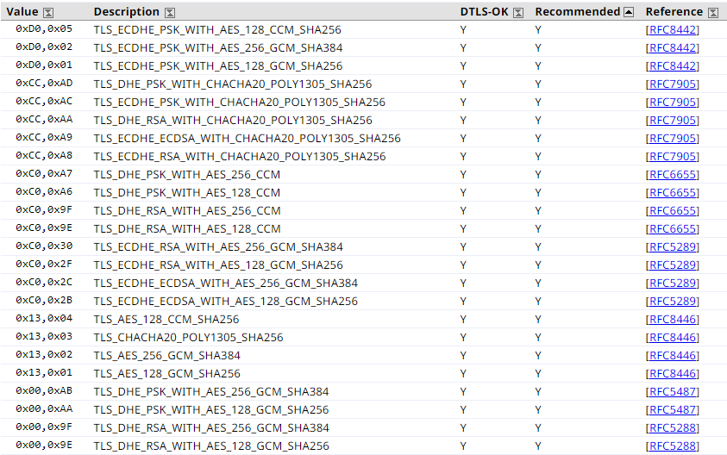
SSL (Secure Sockets Layer):
  - Ubuntu recommends avoiding the deprecated SSL 3.0 in favor of TLS 1.2 and 1.3 to ensure secure communications.
IPsec (Internet Protocol Security):
  - IPsec encrypts communications at the network layer, often used for VPNs. It utilizes AES and 3DES to protect the data being transmitted over the network.
SMB (Server Message Block) 3.0:
  - Samba in Ubuntu uses AES 128 and AES 256 for encrypting file-sharing communications, ensuring confidentiality in shared network environments.
SSH (Secure Shell):
  - SSH is used for secure remote logins and command execution. In Ubuntu 22.04, SSH uses strong encryption algorithms like AES, ChaCha20, RSA, and ECDSA to protect session data.
NTP (Network Time Protocol) and NTS (Network Time Security):
  - NTP ensures the accuracy of system time, which is essential for logging and authentication processes. Ubuntu supports securing NTP using NTS, a protocol that encrypts and authenticates time synchronization with AES-GCM to prevent tampering.

Hashing and Digital Signatures
SHA-256 (Secure Hash Algorithm 256-bit):
  - SHA-256 is widely used for integrity verification, digital signatures, and cryptographic operations in Ubuntu. It ensures that the data remains unchanged and authentic.
SHA-1 and MD5:
  - Although SHA-1 and MD5 are deprecated due to vulnerabilities, they may still exist in legacy systems. It is highly recommended to avoid using these for new implementations and to replace them with SHA-256 or higher.

Ubuntu Updates and Verification
APT (Advanced Package Tool) Service:
  - Ubuntu's APT service downloads and verifies packages through GPG signatures, ensuring that software packages are authentic and unaltered.
  - Updates are transmitted over HTTPS, using TLS for encryption, to prevent tampering and ensure secure installations.
Digital Signatures and Verification:
  - Packages and updates in Ubuntu are digitally signed using GPG keys. The verification process ensures that updates come from trusted sources and that the data is not corrupted or tampered with.

Additional Security Features
AppArmor:
  - AppArmor provides mandatory access control to confine applications to specific permissions, reducing the attack surface and preventing unauthorized access.
ClamAV:
  - ClamAV is an open-source antivirus used to scan for malware, ensuring that system integrity is maintained.
Kerberos:
  - Kerberos is a network authentication protocol that provides strong encryption for communication and supports single sign-on capabilities in Ubuntu, ensuring secure user authentication over the network.
NT LAN Manager (NTLM):
  - Though less common in Linux systems, NTLM support is available through Samba. It uses hash-based encryption to protect authentication data.

